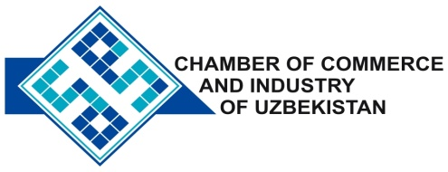

**Commercial offer of Uzbek Products to Foreign Buyer**

Dear Sirs, №TP - 043

We offer quotation of the Uzbek Company LTD «AJAB ETIKETKA»

**Information about the company:**

The company "AJAB ETIKETKA" was founded in 2005 and is the only producer in Central Asia of a wide range of items branded labels for apparel companies, textile and footwear industries.

**List of products:**

Labels printed and woven

**Benefits:**

The company's designers will develop for you design of the label free, despite the fact that this work is usually paid for separately.

**Terms of delivery:** FCA Tashkent

If you are interested, we are happy to provide additional information in accordance with your request.

E-mail: export@chamber.uz

Website: www.chamber.uz

Export Promotion Department.

Chamber of Commerce of the Republic of Uzbekistan.